1. **What is Emmet?**

Emmet is a set of plug-ins for text editors that allow for high-speed coding and editing in HTML, XML, XSLT, and other structured code formats via content assist. It allows you to type shortcuts that are then expanded into full pieces of code.

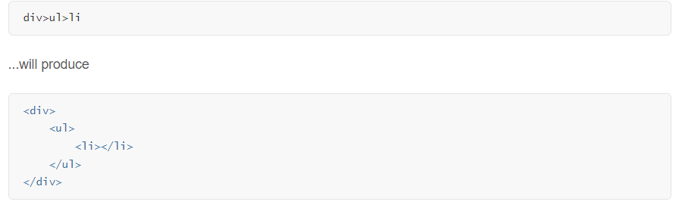

1. **Difference between a Library and Framework?**

A library is not an independently executable unit, but an additional module that is requested by a programme. Libraries are collections of classes and functions, which is why they are sometimes also called component or class libraries. With the help of a programme interface (API / Application Programming Interface), access to the necessary functions from the library is made possible. However, access is only limited to the “public” functions; libraries also have “private” functions that work in the background but remain hidden from the outside world.

A framework is a special kind of library that does not contain “finished” functions like a regular library. Frameworks are rather programme scaffolds that provide the blueprint but not the finished unit.

The framework, therefore, provides the blueprint and the basic framework and shows what is still needed from the programmer in terms of customisation. The framework provides the flow of a software application and tells the developer what it needs and calls the code provided by the developer as required. If a library is used, the application calls the code from the library.

A key difference between is when using a library, the control remains with the developer who tells the application when to call library functions. When using a framework, the control is reversed, which means that the framework tells the developer where code needs to be provided and calls it as it requires.

[Framework vs Library](https://kruschecompany.com/framework-vs-library/#:~:text=The%20framework%20provides%20the%20flow,the%20code%20from%20the%20library.)

| Library | Framework |
| --- | --- |
| Library is a collection of functionalities that we can use in our code to achieve results and provides a way for developers to perform those tasks without having to write all of the code from scratch. | A Framework is a set of tools and conventions for building and organizing code. A framework provides a structure for the code that developers write, and enforces certain conventions and rules for how that code should be organized and structured. |
| React is a JavaScript library for building user interfaces. | Angular is a complete end-to-end framework that provides all of the tools and functionality needed to build a complete web application. |
| It does not provide a lot of the functionality needed to build a complete web application, such as routing, form validation, and state management. As a result, it is often used in combination with other libraries or frameworks to build complete web applications. | It includes a powerful templating system, a dependency injection system, and a lot of other features that make it a full-fledged framework. |
| React is a declarative library, meaning that it allows developers to describe the UI and how it should behave, and the library takes care of rendering the UI and keeping it up to date | s an imperative framework, which means that developers have to write code that explicitly tells the framework how to manipulate the DOM to achieve the desired UI. |
| With a library, developers have more control over how they use the code, and can use it in a variety of different ways. | With a framework, developers have less control, and must follow the conventions and structure set forth by the framework in order to use it effectively. |

1. **What is CDN? Why do we use it?**

A content delivery network (CDN) is a system of distributed servers that deliver web content, such as images, JavaScript files, and CSS stylesheets, as well as dynamic content, such as HTML pages and APIs from a server that is closer to the user, CDNs can reduce the latency and improve the performance of websites and web applications.

1. **Why is React known as React?**

React is named React because of its ability to react to changes in data. When the data in a React component changes, react will automatically re-render the component so that it reflects the new data. This makes it easy to create performant user interfaces that always look up-to-date. React was created by Jordan Walke, a software engineer at Facebook.

React is a JavaScript library for building interactive user interfaces. It is an open-source frontend library developed and maintained by Facebook. In the MVC architecture, it is responsible for the view layer of our application i.e., rendering our user interface and updating the UI whenever the user Reacts or changes the view.

1. **What is crossorigin in script tag?**

The crossorigin attribute sets the mode of the request to an HTTP CORS Request. Web pages often make requests to load resources on other servers. Here is where CORS comes in. A cross-origin request is a request for a resource (e.g., style sheets, iframes, images, fonts, or scripts) from another domain.

CORS is used to manage cross-origin requests. CORS stands for Cross-Origin Resource Sharing, and is a mechanism that allows resources on a web page to be requested from another domain outside their own domain. It defines a way of how a browser and server can interact to determine whether it is safe to allow the cross-origin request. CORS allows servers to specify who can access the assets on the server, among many other things.

The opposite of cross-origin requests is same-origin requests. This means that a web page can only interact with other documents that are also on the same server. This policy enforces that documents that interact with each other must have the same origin (domain).

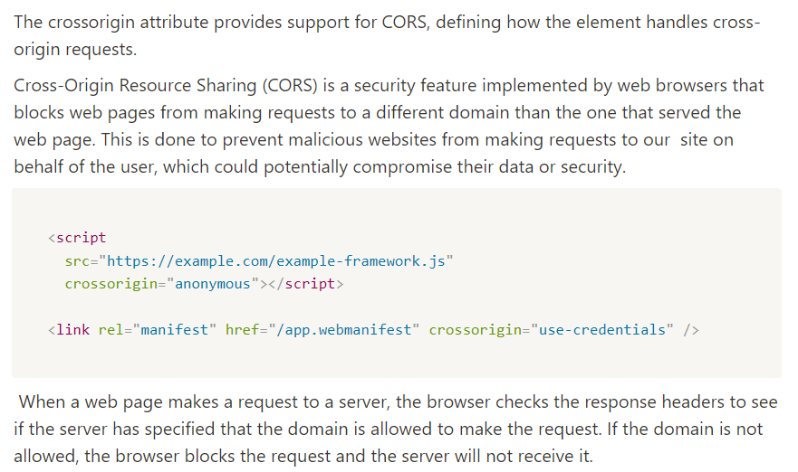

<https://developer.mozilla.org/en-US/docs/Web/HTML/Attributes/crossorigin>

1. **What is difference between React and ReactDOM?**

As React creates a visual representation of our UI. With the help of React DOM library we can perform DOM manipulation based on that Virtual DOM. With ReactDOM we can write React for native applications.

1. **What is difference between react.development.js and react.production.js files via CDN?**

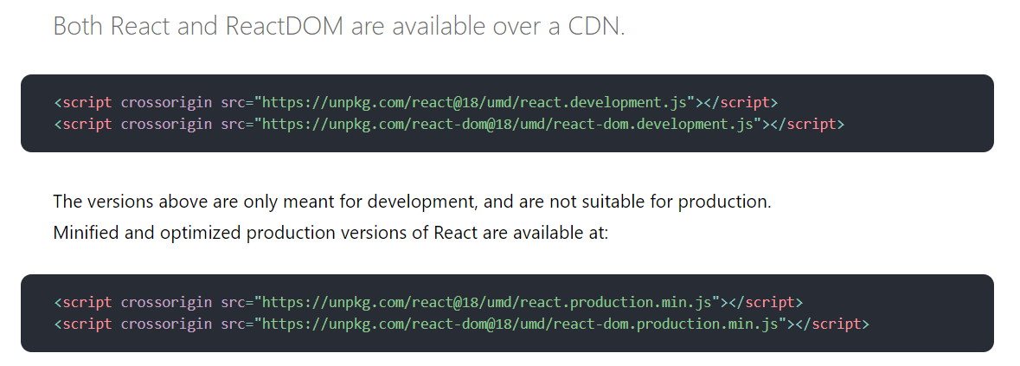

The development version contains helper function such as warnings whereas, in production. all comments are removed and don’t include helper function.

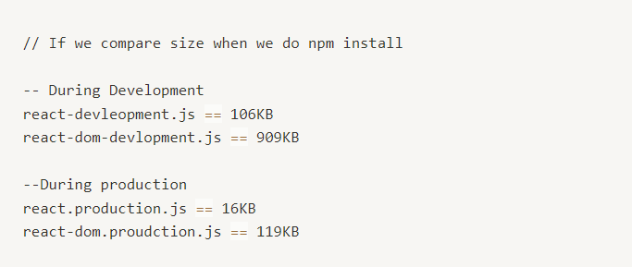

1. **What is async and defer?**

Async - means execute code when it is downloaded and do not block DOM construction during downloading process. Defer - means execute code after it's downloaded and browser finished DOM construction and rendering process.

